From: http://ian56.blogspot.com/2015/05/the-lies-still-being-told-in-media.html

MAY 22, 2015

The Real Reasons the US Invaded Iraq in 2003
The Lies Still Being Told In The Media About The Invasion Of Iraq
The main thrust of the current media disinformation is to try and reinforce the message that the 2003 invasion of Iraq was the result of "faulty" intelligence. Nothing could be further from the truth.
Declassified CIA Document Reveals Iraq War Had Zero Justification
http://www.neonnettle.com/sphere/235-declassified-cia-document-reveals-iraq-war-had-zero-justification-
ALL of the undoctored intelligence reports from the CIA, MI6 etc. concluded that Saddam no longer had any usable chemical weapons. These had been supplied by the US and Rumsfeld in the 1980's to gas the Iranians and Saddam hadn't and wasn't developing anything else.
Hans Blix (the chief UN Weapons Inspector) never missed an opportunity of stating that Saddam no longer had any WMD's - they had all been destroyed or used up in the 1990's. There were others saying the same thing, such as David Kelly.
The intelligence was not faulty. It was accurate.
The intelligence was that Saddam didn't have any WMD's.
The Cheney gang just made up a bunch of lies and the whole of the mainstream media went along with it unquestioningly, despite it being very obvious that Cheney and co. were bare faced lying and their plans for invading Iraq had already been published in PNAC documents from 1997 and 1998.
The reasons the US went to war against Saddam were:-
Saddam refused to do a "oil for arms" deal along the same lines as the Saudis and was becoming independent (this started before the first Gulf War in 1991).
In 2000 Saddam announced he was going to sell oil in Euros and not dollars and encouraged OPEC to do the same. This was a threat to the Petrodollar system and $ hegemony.
The Yinon plan, from the 1980's, for Greater Israel which would extend from the Nile to the Euphrates, covering parts of what is now Egypt, Syria, Lebanon, Jordan, Iraq and Saudi Arabia. In order to achieve this plan all of the surrounding Arab States to Israel have to be turned into chaos and balkanized one by one, so they are weak enough for Israel to fully control.
The invasion of Iraq was specifically designed to:-
Destabilize Iraq and start a civil war.
Dick Cheney knew exactly what he was doing - here he is in 1994 correctly predicting exactly what would happen if the U.S. toppled Saddam
Recruit lots more Islamic Extremist terrorists, to enable future wars or regime changes in neighboring countries to Israel. Libya, Syria, Lebanon and Iran are specified as targets in PNAC, as well as mentions for Afghanistan, Sudan and Somalia.
To very dramatically increase arms spending by the US government and others, thus greatly increasing the profits of arms companies.
To increase the oil price, by limiting Iraq's output of oil.
To make billions for bankers by increasing US government debt.
To personally enrich members of the Bush regime and their cronies. Cheney made over $80m just for himself, then there is the Carlyle Group and its "investors" HW Bush, the Saudis, the Bin Laden family and the Clintons etc.
To use the terrorism threat created by destabilizing the Middle East to shred what was left of the Constitution after the Patriot Act had been enacted.
The "intelligence" used to "justify" the invasion of Iraq was entirely fabricated
As soon as George Bush was installed in the White House in January 2001, Paul Wolfowitz and his Office of Special Plans set to work on cooking up the faked and falsified "intel" that would allow Cheney to invade Iraq after the "new Pearl Harbor" had occurred.
See PNAC. Jeb Bush is one of the 25 original signatories to PNAC. Others included Cheney, Rumsfeld and Wolfowitz
https://wikispooks.com/wiki/Project_for_the_New_American_Century
Paul Wolfowitz is now a "Foreign Policy adviser" to Jeb Bush (as are many others from the GW Bush regime).
General Wesley Clark: Wars Were Planned - Seven Countries In Five Years
Wesley Clark was told one week after 9/11 about the plans to invade / regime change Iraq, Libya, Syria, Lebanon, Sudan, Somalia and Iran
https://www.youtube.com/watch?v=9RC1Mepk_Sw&feature=youtu.be
The Yinon Plan
“Greater Israel”: The Zionist Plan for the Middle East
The Infamous "Oded Yinon Plan"
http://www.globalresearch.ca/greater-israel-the-zionist-plan-for-the-middle-east/5324815
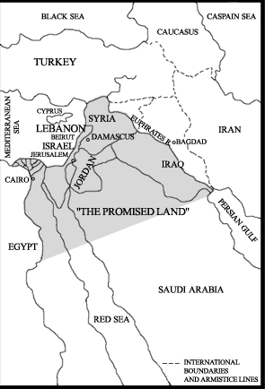
Richard Perle's "A Clean Break"
In 1996 an Israeli think tank published a paper titled "A Clean Break: A New Strategy for Securing the Realm." In this paper the authors, which included Richard Perle (of PNAC fame) and other staunch neoconservatives, advocated goals such as the destabilization of Syria through proxy warfare, and the removal of Saddam Hussein from power in Iraq, in order to create greater 'security' for Israel. Earlier plans called for the use of Islamic fundamentalism to carry out this 'destabilization,' and established the rational behind such a decision:
"[A] possibility, which could even be precipitated by [Islamic] fundamentalism, is what has late been fashionable to call 'Lebanonization.' Most of the states of the Middle East—Egypt is an obvious exception—are of recent and artificial construction and are vulnerable to such a process. If the central power is sufficiently weakened, there is no real civil society to hold the polity together, no real sense of common identity.... The state then disintegrates—as happened in Lebanon—into a chaos of squabbling, feuding, fighting sects, tribes, regions, and parties."
The Shredding of the Constitution for the United States
Obama's Catalog of Civil Rights Abuses and preparations for massive civil unrest
http://ian56.blogspot.com/2012/11/obamas-civil-rights-violations.html
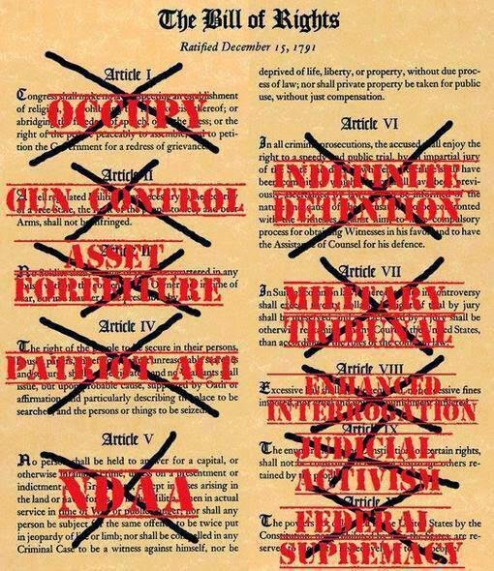
The equivalent actions to undermine free society and democratic processes in the UK (e.g. Snoopers Charter), Australia, Canada (e.g. C-51) and several other countries are documented in here
The number of laws being passed that undermine a free society is increasing around the world
http://ian56.blogspot.com/2013/12/several-recent-laws-and-measures-have.html
War in Libya
Regime change in Libya was performed using Islamic Extremist proxies and a bombing campaign.
The agitation of the existing dissent against Gaddafi had been going on for some time before Libya's civil war started. A further trigger for US action was Gaddafi's 2006 statement that he wanted to start selling oil in Gold Dinars.
The Libyans who fought for al-Qaeda in Iraq against the US had already returned to Libya and many of them were used to fight for al-Qaeda in support of the US to oust Gaddafi.
Chaos and ongoing civil war in Libya has been achieved and it's economy and oil production wrecked.
Libya has been turned into the desired hotbed of extremism for the recruitment, arming and training of further Islamic Extremists.
War in Syria
Gaddafi's weapons hoard has been used to arm Islamic Extremists in Syria.
Benghazi : Libyan gun running & the CIA cover up. Why isn't this as big a scandal as Iran/Contra?
http://ian56.blogspot.com/2014/05/benghazi-libyan-gun-running-cia-cover.html
Syria's civil war was successfully started after many years of the US agitating existing domestic dissent against Assad (from at least 2005).
Obama knowingly armed, trained and funded Islamic Extremist Groups linked to al-Qaeda to topple Assad. They expected this to lead to the declaration of an Islamic Caliphate in Syria / Iraq - which was exactly what happened 2 years later.
DIA Emails: ISIS was deliberately armed and funded by Obama & Hillary Clinton
http://ian56.blogspot.com/2015/06/the-terrorist-threat-has-been.html
The FSA of "moderate" rebels was always largely a fabrication by the Neocons and never comprised that many fighters or any real fighting strength.
Syria has also been turned into chaos and a further recruiting and training ground for terrorists, but the aim of toppling Assad has not been achieved.
Russia has drawn a red line in the sand over the toppling of Assad, and unlike Obama, Putin's red lines can be believed.
War in Ukraine
Putin stopping the mass bombing campaign against Assad in September 2013 provided further impetus for War in Ukraine.
Again agitation of the existing domestic dissent was used to topple the existing regime, as it had been in other previous Coups.
The Coup in Ukraine was designed to wreck Ukraine's economy, start a civil war and turn Ukraine into a failed State. Which has been pretty much achieved.
Turning Ukraine into a failed State was supposed to cause trouble for Putin and enable Russia to be turned into a failed state as well. This has failed and instead it has forced Russia and China closer together faster and hastened the end of American hegemony.
The Neocon plans for complete domination of the entire world are a failure. They were always impractical. As well as the ongoing wrecking of several other countries the result of the Neocons period in power will be the wrecking of America itself (and much of Europe).
One of the many common threads to all of the above has been the Kagans
Donald Kagan is an original signatory to PNAC, one of whose sons is Robert Kagan. (The other is Fred, also a prominent Neocon.)
Robert Kagan is a co-founder of PNAC with Bill Kristol and is the husband of Victoria Nuland.
Victoria Nuland is currently Assistant Secretary of State for European Affairs and was responsible for organizing the Coup in Ukraine and installing Yatsenuk (a self confessed Fascist supporter) as PM in Kiev.
Victoria Nuland was previously the personal adviser to Dick Cheney while he was VP.
The lies and the Neocon wars have not stopped. They are still going on in Syria and Ukraine using proxies. The proxies are ISIS and Al-Qaeda in Syria (and previously Libya), and Nazis in Ukraine.
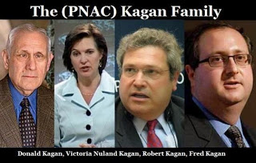
The Kagan Family Business - propagating perpetual war
https://consortiumnews.com/2015/03/20/a-family-business-of-perpetual-war/
There is no end in sight - all the GOP candidates are Neocons and Hillary is a Neocon too
Hillary Clinton's big announcement: I'm running for Goldman Sachs, Saudi Arabia, Soros, Rothschild & Monsanto
http://ian56.blogspot.com/2014/02/if-someone-asks-you-what-you-think-of.html
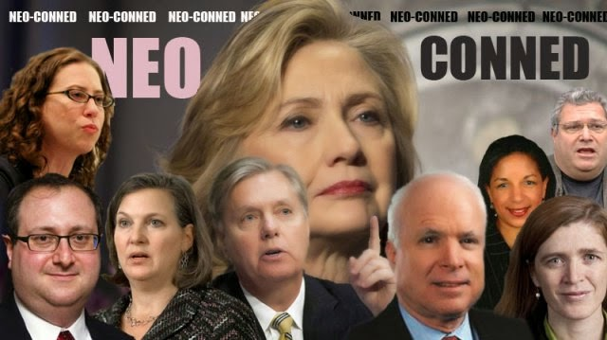
Previous Related Articles
Connecting the dots - The Carlyle Group, Booz Allen Hamilton, The House of Saud, The Bin Laden Family, the Bush's, Funding and Arming Islamic Terrorism, Iraq and the Clintons. A tale of high level corruption in both parties.
http://ian56.blogspot.co.uk/2014/06/joining-dots-carlyle-group-booz-allen.html
Why the US Declared War on Russia
http://ian56.blogspot.com/2015/03/why-us-declared-war-on-russia.html
The Timeline of Events leading up to 9/11 and subsequent events
http://ian56.blogspot.com/2012/10/list-of-us-accomplishments-since-1992.html
Update December 2015
The Neocon "Clean Break" Grand Design & The "Regime Change" Disasters It Has Fostered
http://www.zerohedge.com/news/2015-07-01/short-history-neocon-clean-break-grand-design-regime-change-disasters-it-has-fostere
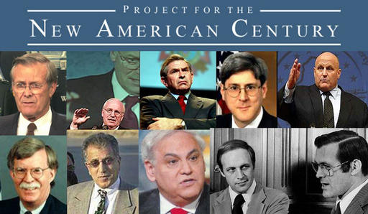

Posted 22nd May 2015 by Ian Shilling

View comments

